**Defect 1**

Bug Name: No add to cart button

Area Path: Buy Again > Item

Severity: Low

Priority: Low

Reported by: Vishal Maru

Reported on: December 14, 2018

Reason: Defect

Status: Active

Environment: Desktop and Mobile Version

Description: Certain Items do not have Add to cart button

Steps to Reproduce:

1. logon into Amazon.com

2. click Buy Again

3. Navigate Add to cart button

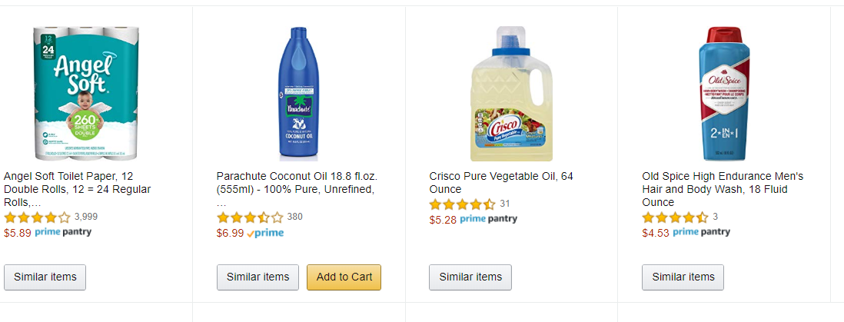

**Defect 2**

Bug Name: random items in Similar Items list

Area Path: Buy Again > Item > Similar Items > Scroll

Severity: Low

Priority: Low

Reported by: Vishal Maru

Reported on: December 14, 2018

Reason: Defect

Status: Active

Environment: Desktop and Mobile Version

Description: random items show up in similar items list for certain items

Steps to Reproduce:

1. logon into Amazon.com

2. Click Buy Again

3. Click similar items for certain items

4. Scroll through

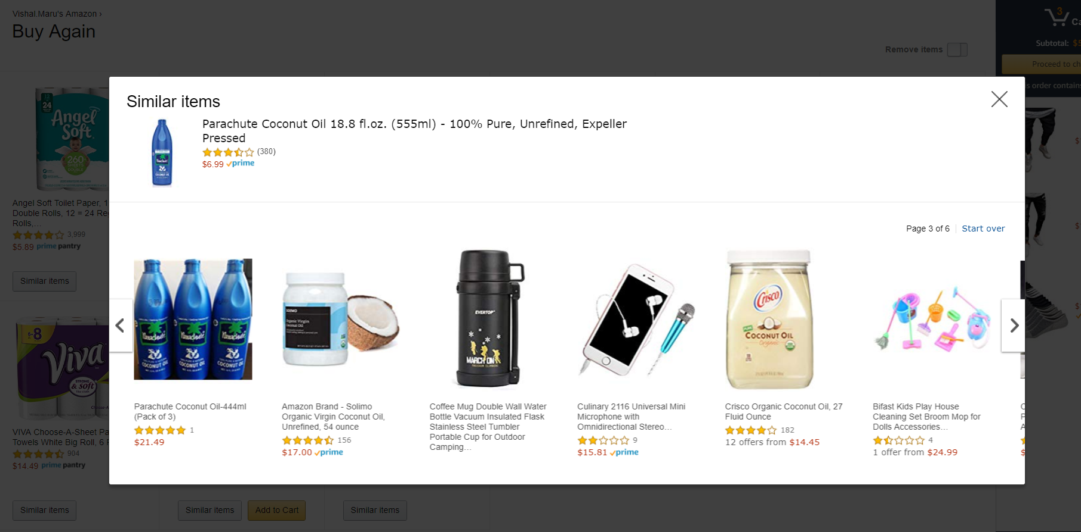

**Defect 3**

Bug Name: Not everything included in Buy Again List

Area Path: Amazon.com > Buy Again

Severity: Medium

Priority: Medium

Reported by: Vishal Maru

Reported on: December 14, 2018

Reason: Defect

Status: Active

Environment: Desktop and Mobile Version

Description: Not all the products from previous purchases are included in Buy Again

Steps to Reproduce:

1. logon into Amazon.com

2. Navigate to Accounts & Lists > Your Orders. Note the orders

3. Click Buy Again Tab

4. Orders from previous orders are not included

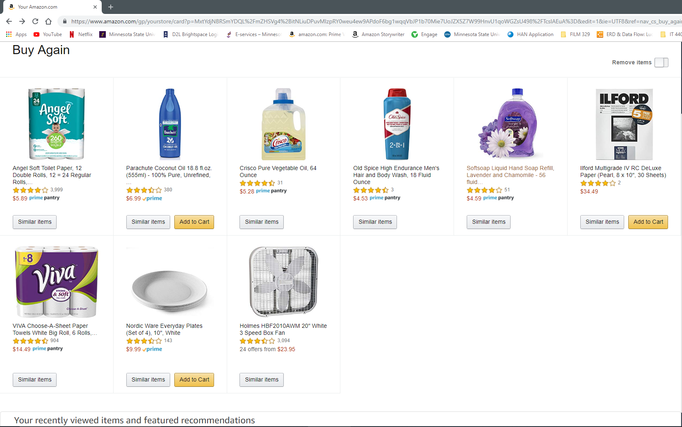

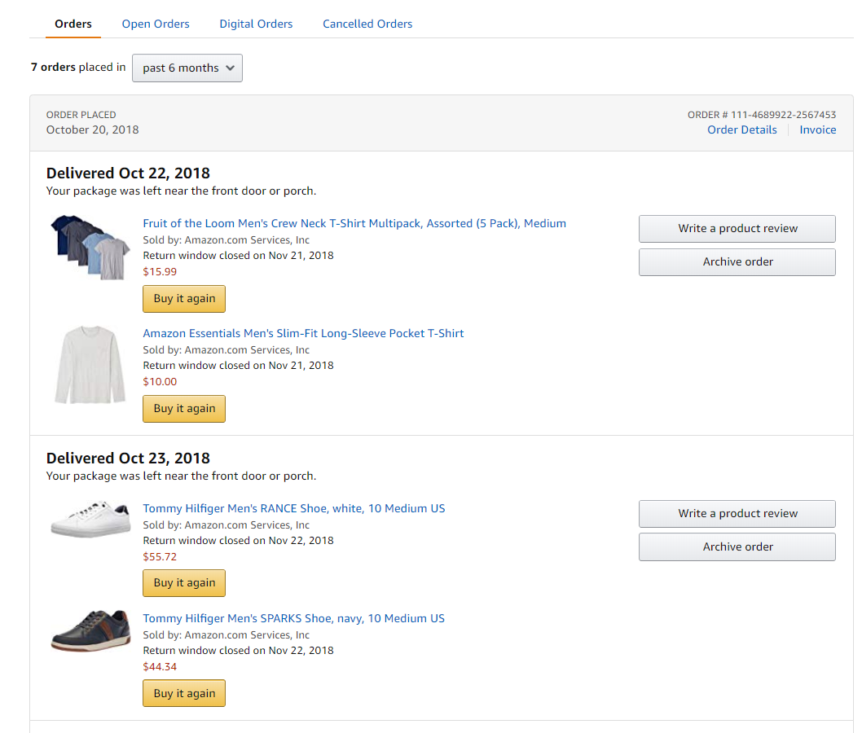

**Defect 4**

Bug Name: No Similar Item button on Mobile Version

Area Path: Amazon App > Hamburger button > Buy Again

Severity: Medium

Priority: Low

Reported by: Vishal Maru

Reported on: December 14, 2018

Reason: Defect

Status: Active

Environment: Amazon Mobile App

Description: Items in Buy Again list on the mobile app do not have similar items button to find similar items.

Steps to Reproduce:

1. logon into Amazon App

2. click hamburger Button on top left

3. click Buy Again

4. No similar Items button

